**A PROJECT TOPIC PROPOSAL**

**FOR**

**REMOTE HAND GESTURE CONTROLLED ROBOT**

|  |  |  |  |
| --- | --- | --- | --- |
| S/N | NAME | MATRIC NO. | SCHOOL EMAIL |
| 1. | OWOLABI JOSHUA OLUWASEGUN | EEG/2017/097 | joshuaowolabi@student.oauife.edu.ng |
| 2. | EKUNDAYO BOLUWATIFE ARINOLA | EEG/2017/049 | baekundayo@student.oauife.edu.ng |
|  |  |  |  |
|  |  |  |  |

**ABSTRACT**

For this project, We will be designing a Remote Hand Gesture Controlled Robot - A robot that can be controlled with the movements of the controller’s hand. We will use an Inertial Measurement Unit (IMU) to measure the orientation/tilt of the controller’s hands and translate this information to control the direction/speed of the robot (Toy Car).

**INTRODUCTION**

Robots are playing an essential role in automation across all sectors like construction, military, medical, manufacturing, etc. We want to develop this IMU-based gesture-controlled robot with an ESP32 WiFi LoRa Module. A gesture-controlled robot is controlled by using the hand in place of any other method like buttons or joystick. Here one only needs to move the hand to operate the robot. A transmitting device is placed in the user's hand, which contains the ESP32-WiFi-LoRa Module and MPU6050(IMU) to transmit a command to the robot so that it can perform the required task of moving forward, back, turning left, right and stop.

**WORKING PRINCIPLE**

Our gesture-controlled robot works based on MPU6050 outputs, which correspond to hand movements and sends that data through the LoRa module to the Receiver circuit. On the other end, the information is received wirelessly via the LoRa module. These decisions are sent to the motor driver, which triggers the motors in specific configurations to make the robot move in different directions.

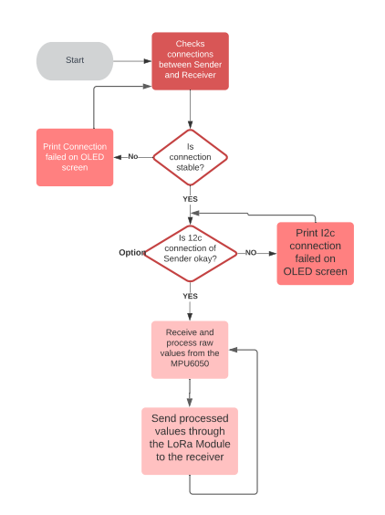

**Figure 3.0: Flowchart of the Sender Circuit**

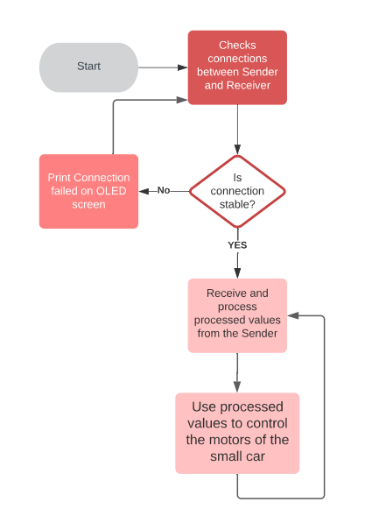

**Figure 4.0: Figure 3.0: Flowchart of the Receiver Circuit**

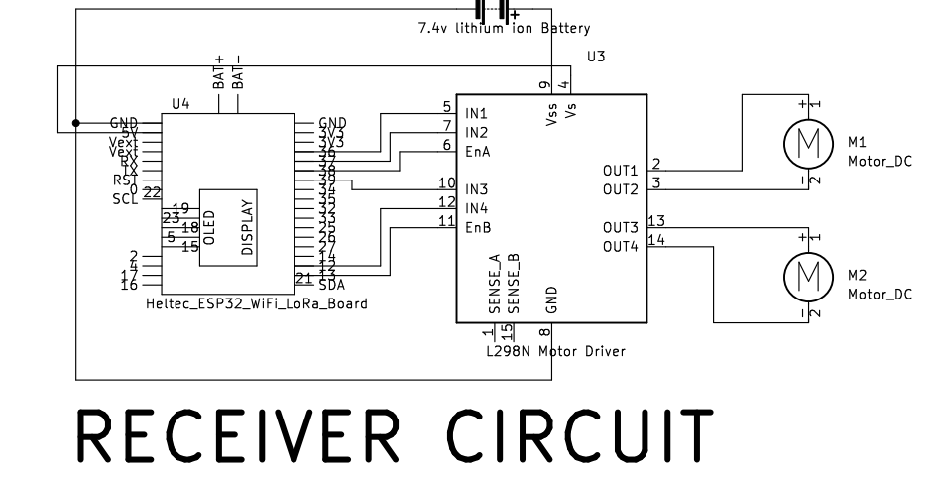

**Figure 1.0: Receiver circuit of the Hand Gesture Control Robot**

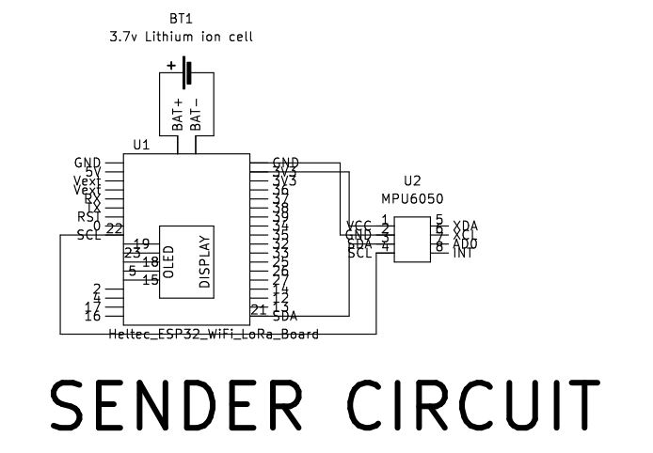

**Figure 2.0: Sender circuit of the Hand Gesture Control Robot**

**HARDWARE REQUIREMENTS**

**CONCLUSION**

In this project, we introduced a hand-gesture-based interface for navigating a car-robot. A user can control a car-robot directly by using his or her hand trajectories. In the future, we could directly use a mobile phone with an accelerometer to control a car-robot. We also want to add more hand gestures (such as the curve and slash) into the interface to control the car more naturally and effectively.

**REFERENCES**

[*https://www.ijert.org/research/hand-gesture-controlled-robot-IJERTV9IS110014.pdf*](https://www.ijert.org/research/hand-gesture-controlled-robot-IJERTV9IS110014.pdf)